Operational Plan SPFx – Installation Guide

Overview
Installing Operational Plan SPFx takes five steps. An admin uploads it to the App Catalog once, then a site owner installs it on each site. The package does not create lists when the app is added: the Operational Plan web part creates them from a page.
- Get site admin access to the App Catalog (one time).
- Upload the .sppkg to the App Catalog (one time, or for each new version).
- Add the app to the target site.
- Add the Operational Plan web part to a page and click Provision lists.
- Verify the lists and publish the page.
In the URLs below, replace <tenant> with your organization's SharePoint tenant name and <your-site> with the site you are installing on. Your App Catalog may use a different path than /sites/appcatalog; use the one shown in your SharePoint admin center.

Prerequisites and access
What | Who needs it | Why
SharePoint admin center access (SharePoint Administrator role) | Person uploading the app | Reach Active sites and the App Catalog
Site admin on the Apps site (/sites/appcatalog) | Person uploading the app | Without it the Upload button is hidden
Site owner on the target site | Person installing the app | Add an app and edit pages
Manage Lists permission on the target site | Person provisioning | The web part checks this before creating lists
The .sppkg file | Person uploading the app | The Operational Plan SPFx package

Admin center access alone is not enough to upload. The App Catalog shows a banner, "To manage apps, you need to add yourself as a site admin to the Apps site", until step 1 is done.

Step 1: Get App Catalog site admin access
This is a one-time setup for each person who will upload packages.
- Open the SharePoint admin center (https://<tenant>-admin.sharepoint.com).
- In the left menu, go to Sites → Active sites.
- Find and click the Apps site (type: App Catalog Site, URL ending /sites/appcatalog).
- In the panel that opens, select the Membership tab, then Site admins.
- Click + Add site admins, enter your name or email, and click Add.
- Wait a few minutes for the permission to apply.

Step 2: Upload the .sppkg to the App Catalog
Uploading makes the app available to every site, but it does not install it anywhere or create any lists.
- Open Manage apps: https://<tenant>.sharepoint.com/sites/appcatalog/_layouts/15/tenantAppCatalog.aspx/manageApps. From the admin center, the same page is under More features → Apps → Open.
- Refresh the page. The site admin banner should be gone and Upload should show in the command bar.
- Click Upload and choose the Operational Plan SPFx .sppkg file.
- If a deploy dialog appears, click Enable.
- Confirm the row in Apps for SharePoint:
- Title: Operational Plan SPFx
- State: Enabled
- Valid app package: Yes
- Added to all sites: Not applicable (it is installed site by site)
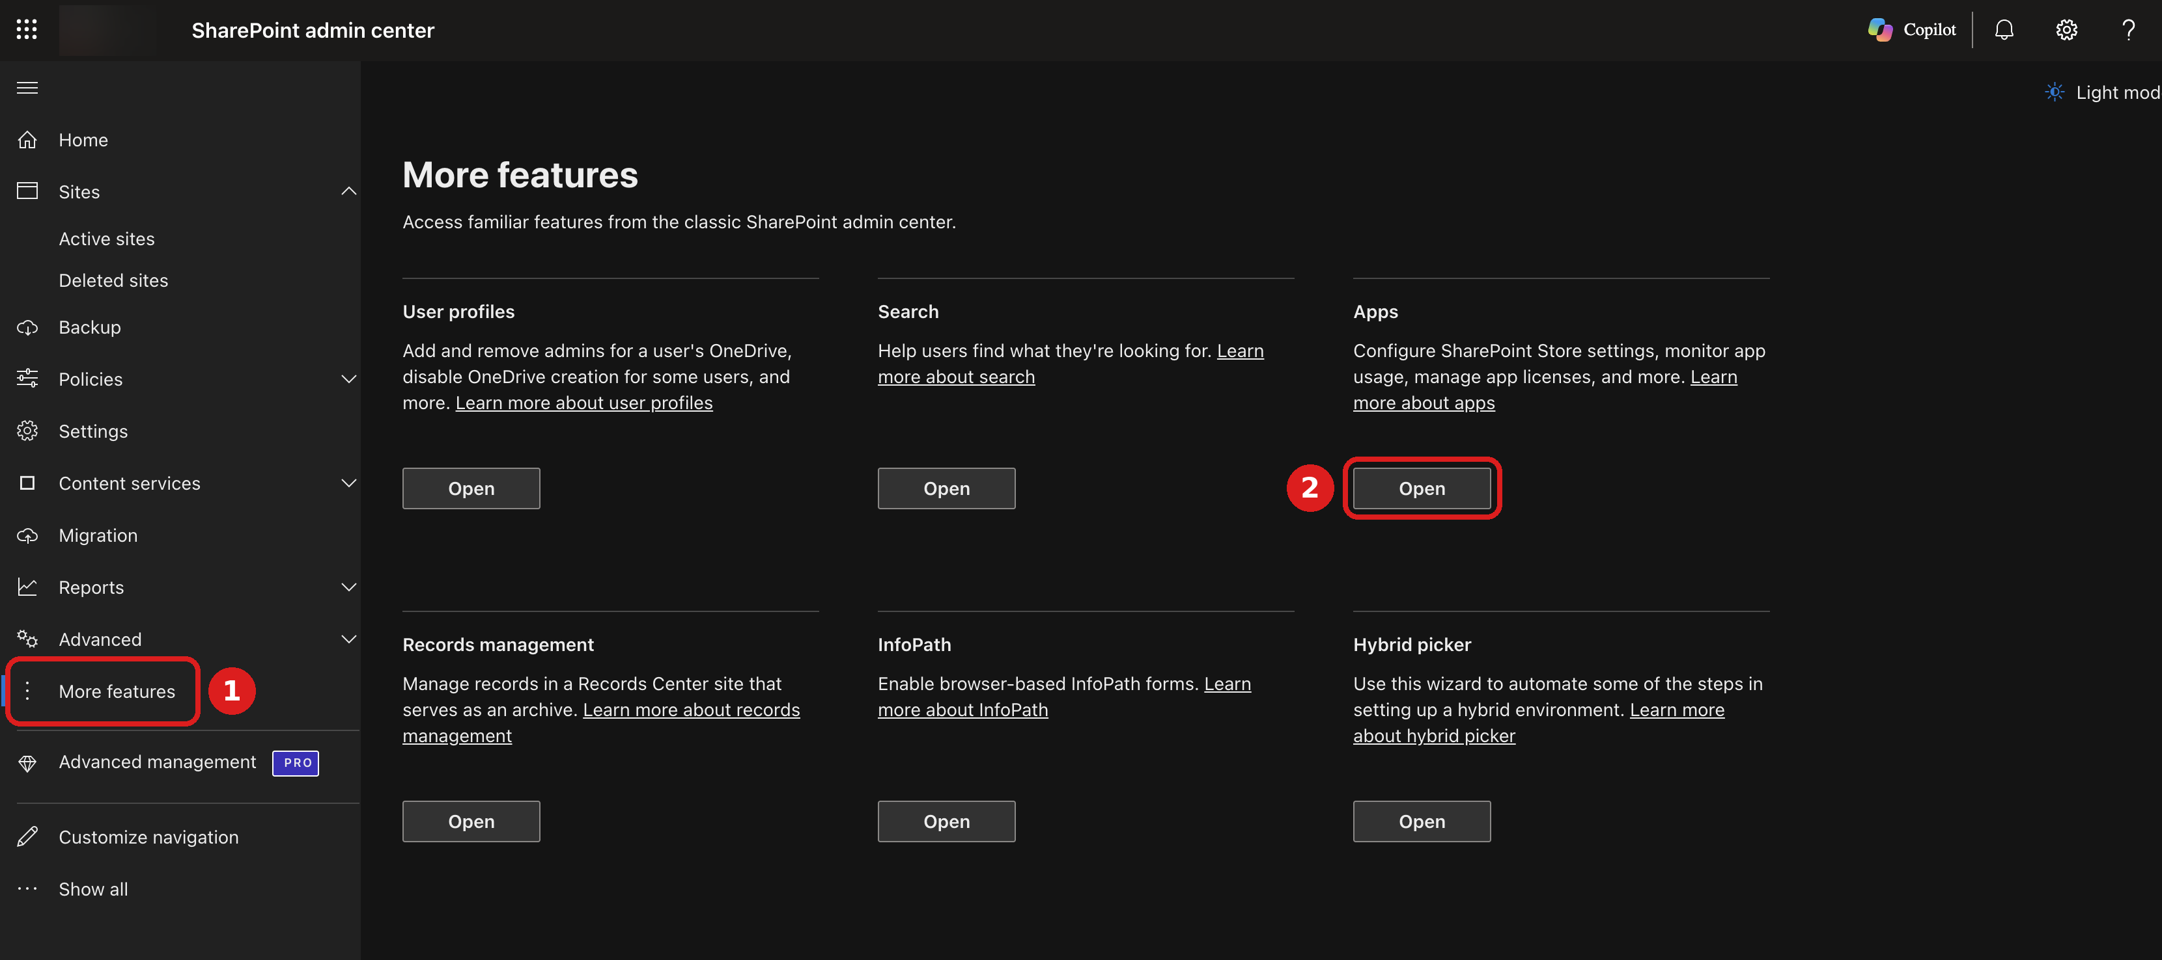
Figure 1. SharePoint admin center: (1) More features, then (2) Open under Apps.
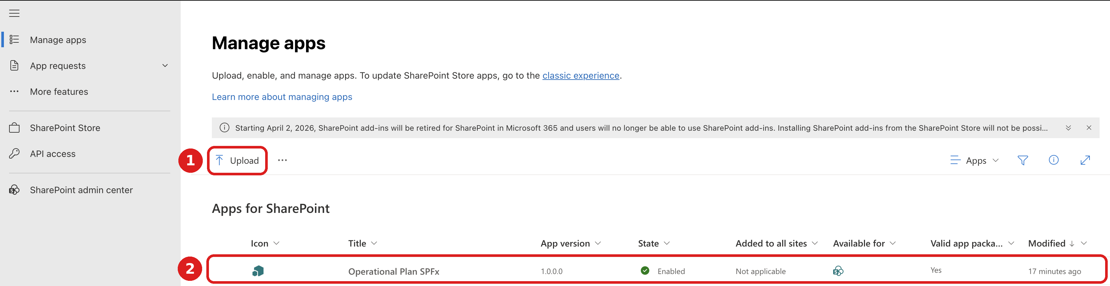
Figure 2. Manage apps: (1) Upload the .sppkg, then (2) confirm the Operational Plan SPFx row shows Enabled.
Once enabled, any site owner can add the app from their site. To pause that during testing, select the app in Manage apps and disable it.

Step 3: Add the app to the site
Repeat this step on every site that will use Operational Plan.
- Open the target site (https://<tenant>.sharepoint.com/sites/<your-site>).
- Click Settings (gear) → Add an app.
- Under Apps you can add, find Operational Plan SPFx and click Add.
- Wait about a minute. The app moves to Added apps.
- Check Settings → Site contents. Operational Plan SPFx is listed with type App.
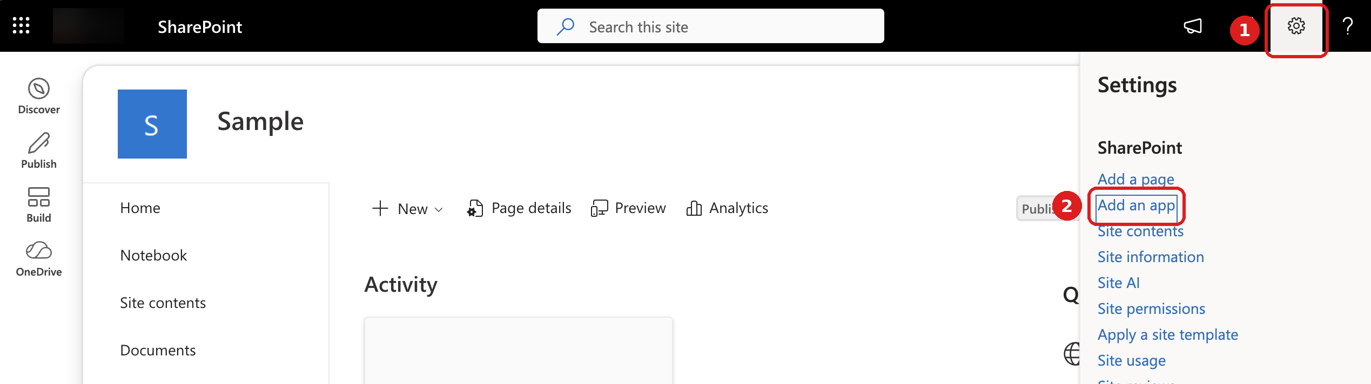
Figure 3. On your site: (1) Settings (gear), then (2) Add an app.
No lists appear yet. That is expected: step 4 creates them.

Step 4: Add the web part and provision the lists
- Go to the site Home page and click Edit at the top right.
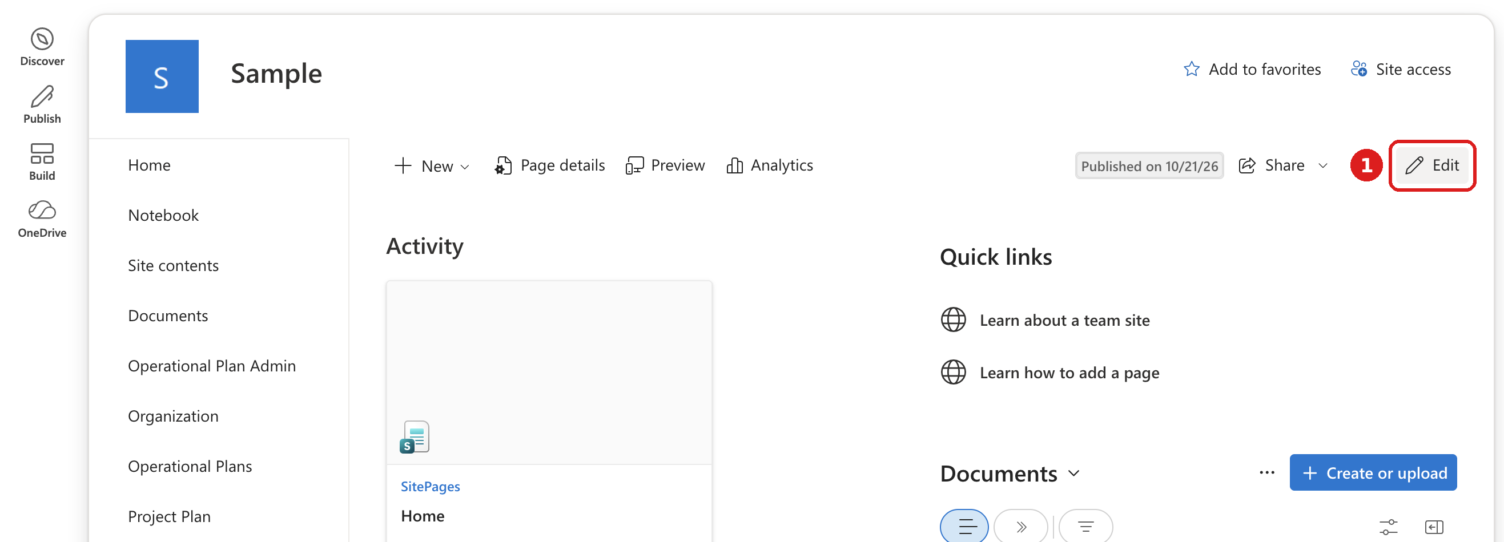
Figure 4. Click Edit on the site Home page.
- In the Toolbox panel on the right, search Operational. Alternatively, click a + circle on the page and search there.
- Click the Operational Plan web part (database icon) to add it to the page.
- Read the Pre-flight check. It should say you have Manage Lists permission and list the lists below as Missing.
- Click Provision lists and wait until the Progress section shows all five lists finished.
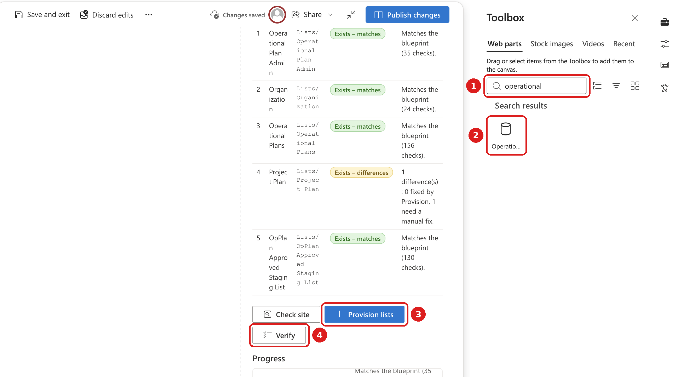
Figure 5. Page edit mode: (1) search Operational in the Toolbox, (2) add the web part, (3) Provision lists, (4) Verify.
List | URL | Fields created
Operational Plan Admin | Lists/Operational Plan Admin | 2
Organization | Lists/Organization | 1
Operational Plans | Lists/Operational Plans | 14
Project Plan | Lists/Project Plan | 11
OpPlan Approved Staging List | Lists/OpPlan Approved Staging List | 12

Step 5: Verify and publish
- ☐ Click Verify in the web part and confirm every list and field passes.
- ☐ Open Settings → Site contents and confirm the five lists are there.
- ☐ Open a list (for example Operational Plans) and check the columns.
- ☐ Click Publish changes to keep the web part on the page, or Discard edits if it was only used for setup.

Troubleshooting
Problem | Cause | Fix
No Upload button in Manage apps | Not a site admin of the Apps site | Do step 1, wait a few minutes, refresh
No lists after adding the app | Expected: adding the app does not create lists | Do step 4
Web part not found in the Toolbox | App not added to this site yet | Do step 3, then refresh the page
Pre-flight says you can't provision | No Manage Lists permission on the site | Ask a site owner to provision, or to raise your permission
Lists show as existing, not Missing | Lists from an earlier install are still there | Use them as they are, or delete them and provision again
A list shows Exists – differences | The existing list differs from the expected setup | Read the Details column, fix anything marked as needing a manual fix, then click Verify

Deleted lists go to the site Recycle bin and can be restored from there.

